1. Write a SQL Statement to create a database.

create database practice;

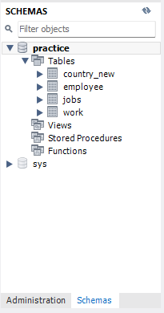

1. Write a SQL statement to create a table named countries including columns country_id,country_name, and region_id, and make sure that no duplicate data against column country_id will be allowed at the time of insertion.

create table countries(

country_ID int primary key,

country_name varchar(25),

region_ID int

);

1. Write a SQL statement to create a table named jobs including columns job_id, job_title, min_salary, and max_salary, and make sure that the default value for job_title is blank and min_salary is 8000 and max_salary is NULL will be entered automatically at the time of insertion if no value assigned for the specified columns.

create table jobs(

job_ID int primary key,

job_title varchar (25),

min_salary int default (8000),

max_salary int null

);

1. Write a SQL statement to create a table employee including columns employee_id, first_name, last_name, email, phone_number hire_date, job_id, salary, commission, manager_id, and department_id

create table employee(

employee_ID int primary key,

first_name varchar(15),

last_name varchar(15),

email varchar(50),

phone_number int (10),

hire_date date,

salary int,

commission int,

manager_ID int,

department_ID int

);

1. Write a SQL statement to insert a record with your own value into the table countries against each column.

insert into countries value(1,'india',1),(2,'china',2),(3,'japan',3),(4,'korea',4),(5,'thailand',5);

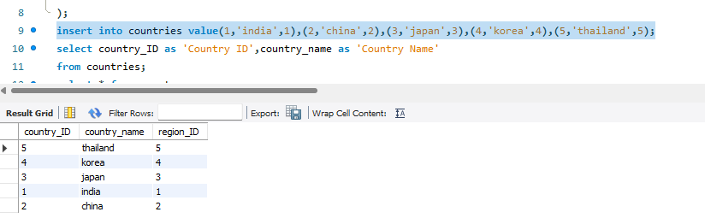

1. Write a SQL statement to insert a record with your own value into the table jobs against each column.

insert into jobs(job_ID) value (001);

insert into jobs(job_ID) value(002);

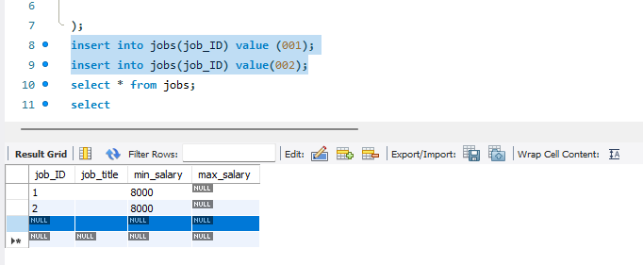

1. Write a SQL statement to insert one row in the jobs table to ensure that no duplicate value will be entered in the job_id column.

job_ID int primary key,

8.Write a SQL statement to rename the table countries to country_new.

rename table countries to country_new;

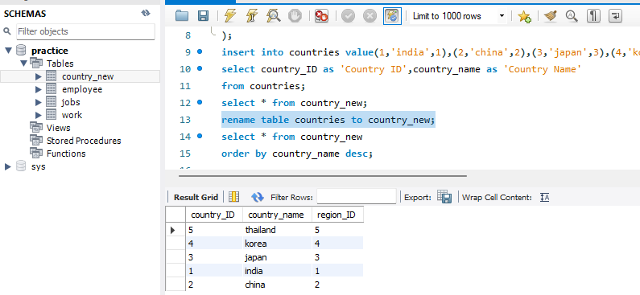

9.Write a query to display the names (country_id, country_name) using alias name “Country ID", "Country Name"

select country_ID as 'Country ID',country_name as 'Country Name'

from country_new;

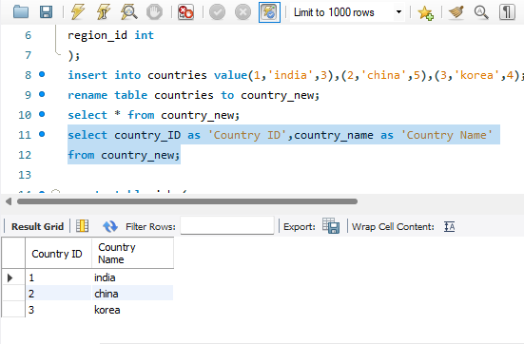

10.Write a query to get all country details from the countries table order by country_name, descending.

select *from country_new

order by country_name;

